Asia-China-Coin-6.27 R3-Round-250-220 BCE-State of Qin

重一两十四珠, Zhu Zhong Yi Liang Shi Si (DCD reading). One coin weight one liang [series no.] 12. The liang consisted of 24 zhu, and this coin weighs 14 gms. Also called "珠重一两十四". Round coin which was made & used in the Qin Nation,Middle & Late Warring states period."珠"means coin,"重一两"weight,"十四"marks year or number, dia. 3.65 cm./1.44 in.

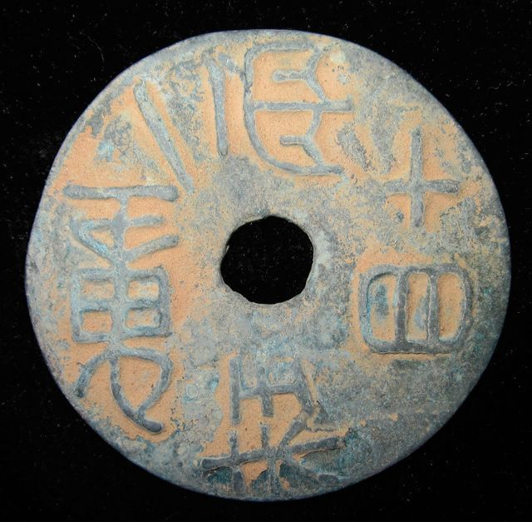

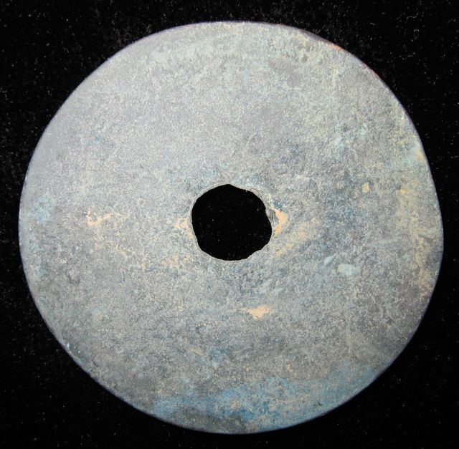

Order details Printer friendly page

Sold by

[cnrelics](http://myworld.ebay.com/cnrelics) ( [18](http://feedback.ebay.com/ws/eBayISAPI.dll?ViewFeedback&userid=cnrelics)  )

+ Show additional actions

Delivery package 1 of 1

Estimated delivery Thursday, Feb 6, 2014 - Thursday, Mar 6, 2014

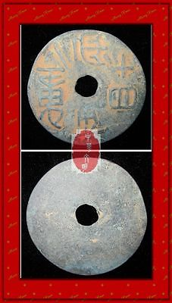

[WARRINGSTATESPERIOD QIN NATION WEIGHT 14YEAR NUMBER MONEY BRONZE COIN重一两十四珠1.44"](http://www.ebay.com/itm/151203809683)

Item price

$69.99

Quantity

1

Item number

151203809683

Shipping service

Economy Shipping from outside US

[Leave feedback](http://feedback.ebay.com/ws/eBayISAPI.dll?LeaveFeedbackShow&useridfrom=802-867&useridto=cnrelics&item=151203809683&transactid=0) [Contact seller](http://contact.ebay.com/ws/eBayISAPI.dll?FindAnswers&frm=3998&iid=151203809683&redirect=0&requested=cnrelics) [Return item](http://return.ebay.com/ws/eBayISAPI.dll?ResolveReturn&eventName=viewSelectedItem&TransactionId=0&ItemId=151203809683)

### Order total

Subtotal $69.99

Shipping $10.00

#### Total

## $79.99

[View PayPal transaction](http://payments.ebay.com/ws1/eBayISAPI.dll?IntermediateResolutionInfo&itemid=151203809683&transId=0&pn=UnifiedCheckoutSummaryRedirect2PP&qs=itemid%3D151203809683%26transId%3D0%26buyerorseller%3D0%26)

### Order information

Order placed on  
Friday, Jan 17, 2014

Having a problem with this purchase?  
[Resolve problem](http://res.ebay.com/ws/eBayISAPI.dll?ResolutionCenter)

Payment method   
PayPal

Payment date  
Friday, Jan 17, 2014